How do I sign up for a Canvas account as a Parent?

Parents (Observers) can link their Canvas account to their student's account so they can see assignment dues dates, announcements, and other course content.

- These steps must be completed through the web version of Canvas. The observer signup process cannot be done through the mobile app.

1. Open Canvas URL:

https://cityacademyslc.instructure.com/login/canvas

2. Click to create a Canvas account
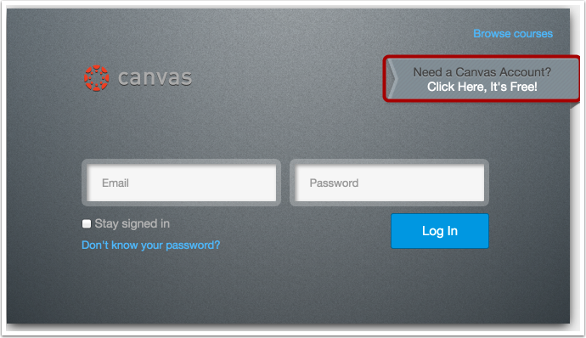

3) Sign Up As a Parent (Free Account)
Click the Parents sign up here link.

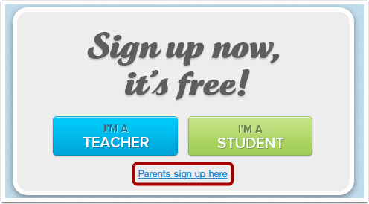
Enter the following information:

- Enter your name in the name field.
- Enter your email in the email field.
- Enter your child's username in the child's username field.
- Enter your child's password in the child's password field.
- Agree to the terms of use by clicking the You agree to the terms of use check box.
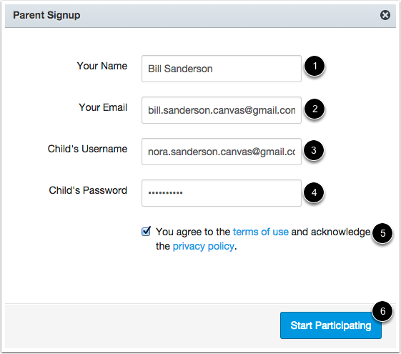
- Click the Start Participating button.
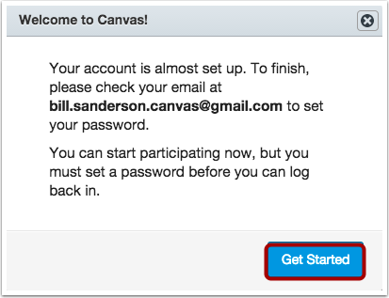
While your account is not entirely set up, you can begin participating in Canvas immediately by clicking the Get Started button. To finish registering for Canvas, log into your email account.

4) Complete Registration Process
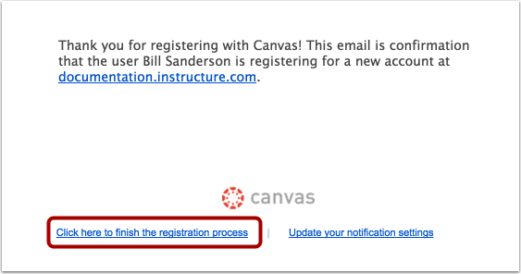
Open the email from Instructure Canvas. Click the link provided to visit the provided URL and complete the registration process.

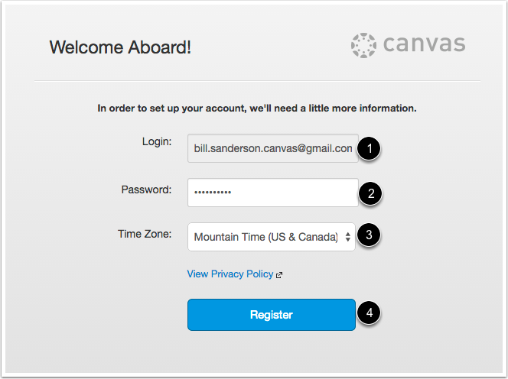
To complete the registration process fill out the following fields:

- Verify your email in the login field.
- Set your password by typing in the password field.
- Set your timezone by selecting the time zone drop-down menu.
- Click the Register button. You will be redirected to the Canvas URL login page for your account.

5) View User Dashboard
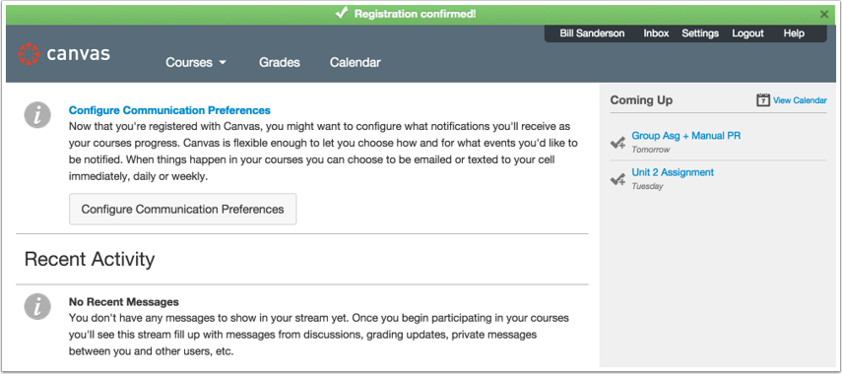
View the user dashboard for your Canvas account.

View Course
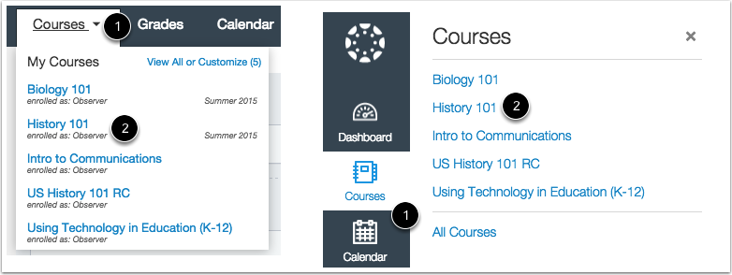
In Global Navigation, click the Courses link [1], then click the name of the course [2].

How do I link to another student as an Observer?
If you signed up for a Canvas account as a parent and linked yourself to a student, you can add additional students to observe within the same institution.

Click the Settings link [2].

Open Observing
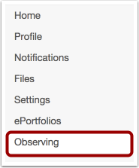
In User Navigation, click the Observing link.

Add Student
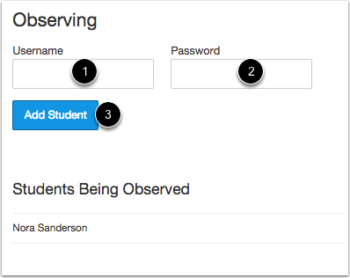
In the Username [1] and Password [2] fields, enter the student's username and password.

Click the Add Student button [3].

View Student
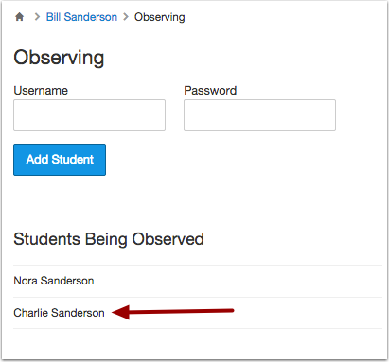
View the new student you are observing.

